L I B R A R Y M E D I A C E N T E R
DIGITAL RESOURCES
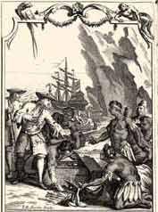
American Journeys | Biography.com | Chronicles of American History
CIA World Factbook | Citation Generator | CultureGrams
Destiny Discover | Ducksters History Education | EBSCOhost
Handbook of Texas Online | History Matters | National Geographic
National History Day Website | National Archives and Records | NASA
Portal to Texas History | CIA Spy Kids | StoryboardThat
TexQuest | WorldBookOnline Encyclopedia

